1)ls

2)ls -l

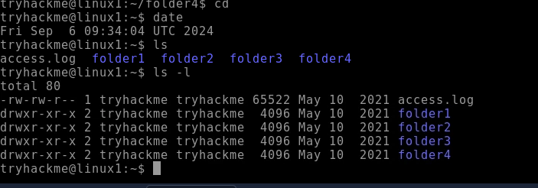

3)whatis

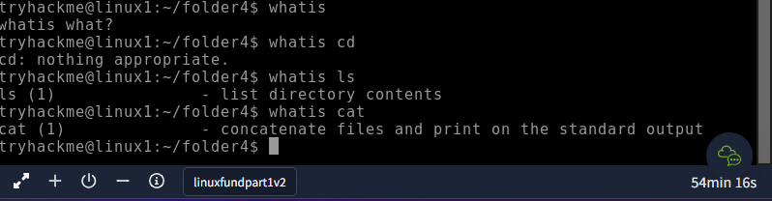

4)cd

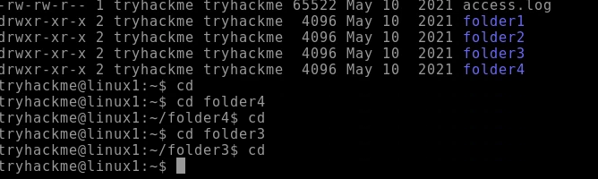

5)pwd

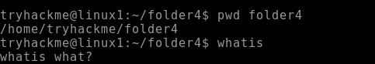

6)man

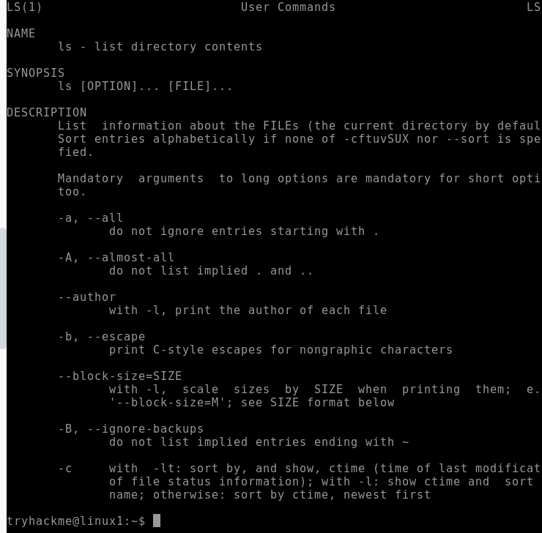

7)mkdir

8)rmdir

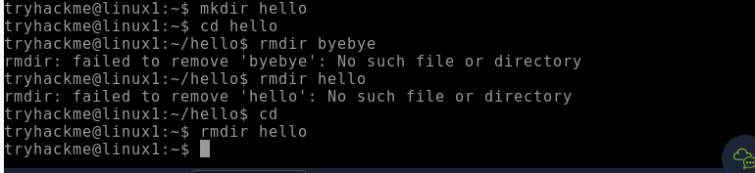

9)cal

10)date

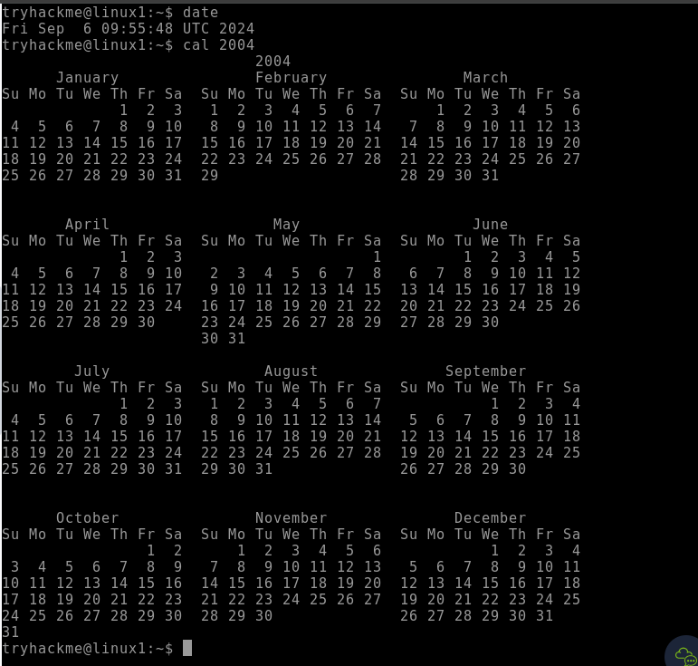

11)echo

12)cat

